Machrihanish Seabird Observatory (MSBO)
October Records 2014

Compiled by Eddie Maguire (warden)
Full-time assistant warden Iomhar McMillan
Unless stated photos in this report are by the warden.

MSBO Photo of the Month...
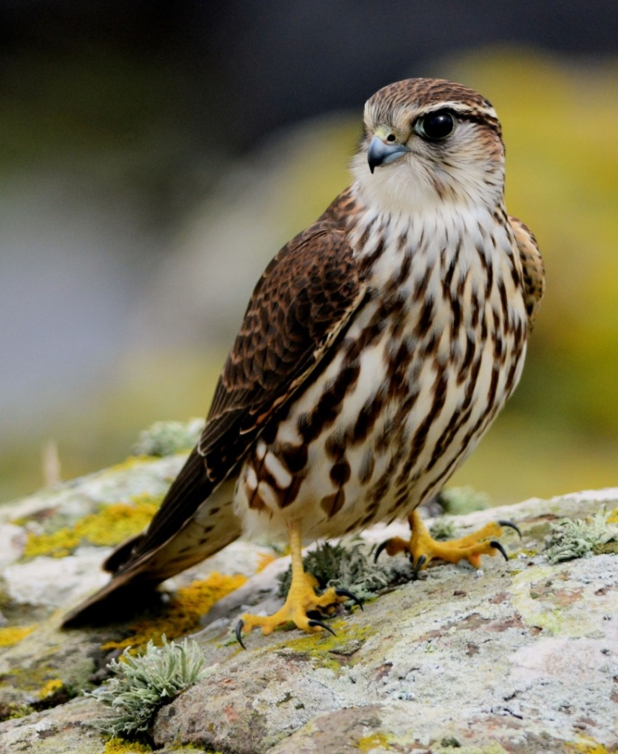
Merlin – a first-winter bird close to MSBO

UK Twite Study Project 2010-2014...
This valuable project continued. However, owing to the weather, only 26 Twite were colour-ringed this month. Additional species trapped in the pull net system / ringed included 18 Goldfinch and 10 Chaffinch.

Cumulative totals September / October = Twite 221
Goldfinch 157
Chaffinch 14
Linnet 2

Grand total ringed 394
Recent MSBO colour-ringed Twite sightings...
Already, 3 birds have been reported elsewhere: two ringed this autumn were spotted in a flock of 45 birds on 9th October at Ballintoy Harbour on the north coast of Co Antrim (Richard Donaghey pers. comm.) and another, ringed on 10th September, was controlled at Point of Ayr, Isle of Man on 29th October (Sean Gray pers. comm.).

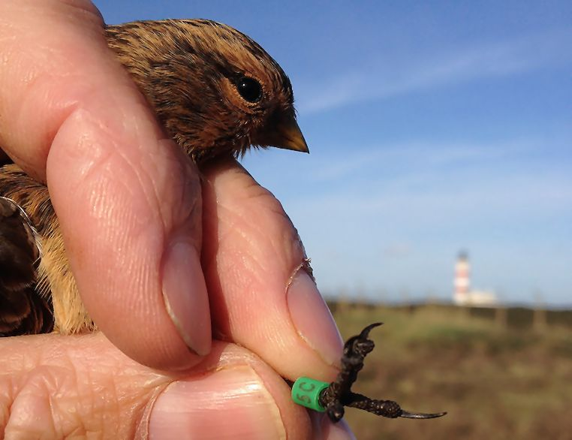
Twite 5C was ringed at MSBO 10th September / controlled Isle of Man 29th October: Photo Sean Gray

Additional Sheltered area at MSBO

The unfinished construction below, being used at present as a viewing platform, was built this month. Eventually it will provide sheltered access for visitors at all times to enjoy birds and other wildlife over adjacent uplands and shore / marine habitats.
The planned hide (half the size of the platform) will be completed when funding becomes available.

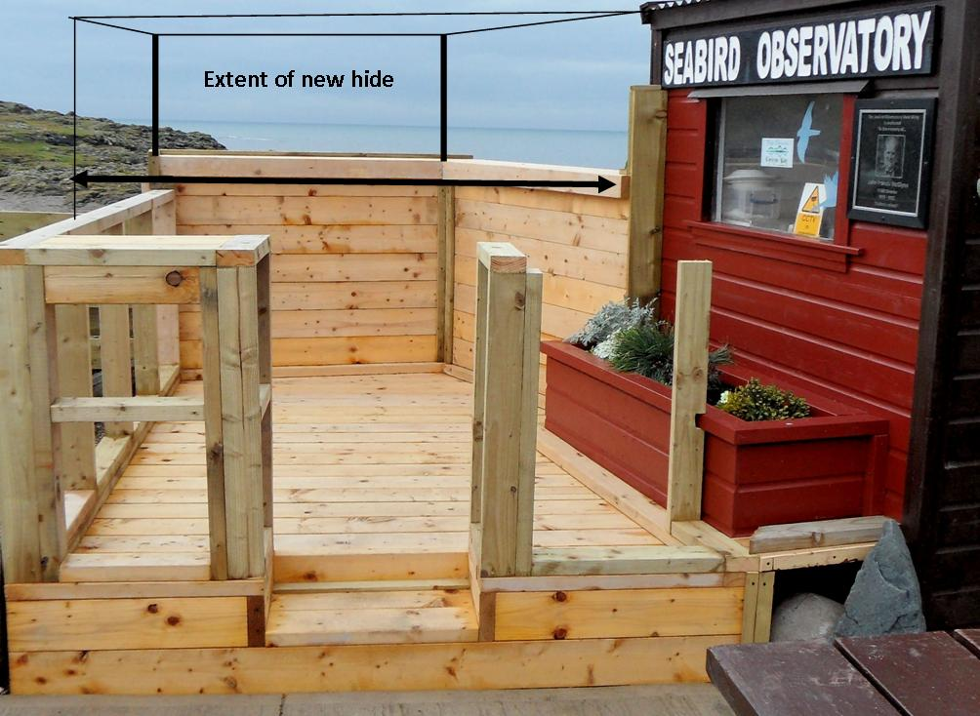

Origin / wandering behaviour of a colour-ringed Black Swan...

The colour-ringed Black Swan that arrived in Campbeltown Loch on 4th August 2014 is now known to be the wandering female of a high profile celebrity pair named ‘Barak’ and ‘Michelle’. They were gifted to Sir Gerry and Lady Heather in 2011 for their impressive Oakfield Park lakes at Raphoe Castle Estate in Co Donegal.
Michelle initially took off from Oakfield Park in summer 2012 and by all accounts held up in Stranraer (Dumfries and Galloway) for a while before heading back west for the bright lights of Belfast in December 2012.
She was caught at Belfast Waterworks City Council Park by a BTO ringer and fitted with a bright orange darvic ring bearing three black letters ‘NIY’ and returned to Oakfield Park, Donegal the same day (15th December 2012).
Michelle’s recent bid for freedom has brought her back to Scotland.
After spending around six weeks in Campbeltown Loch she was last seen there on 19th September 2014 and a week or so later at Peninver.
David Jardine (pers. comm.) saw a Black Swan distantly at the Add Estuary, Mid Argyll on 5th October but not later. It seems more than likely this was Michelle.
Then, on 16th October, she suddenly appeared back in Campbeltown Loch (Emma Moffat / Elsie Campbell et al / pers. comm.). A Black Swan was seen again in Mid-Argyll (Ulva Lagoons) on 24th (Paul Daw). Could this be Michelle wandering again?
All future sightings of ‘NIY’ from anywhere away from Campbeltown, especially Argyll, will be gratefully received and acknowledged.
Many thanks to Rab Morton (Sanda Island Bird Observatory) for his thoroughness in tracing Michelle’s Co Donegal origin, and bringing to light, the history of her wandering ways.

Summary of the month at MSBO...

The fourth Leach’s Petrel of the autumn was photographed >S during a NW storm event on 21st.
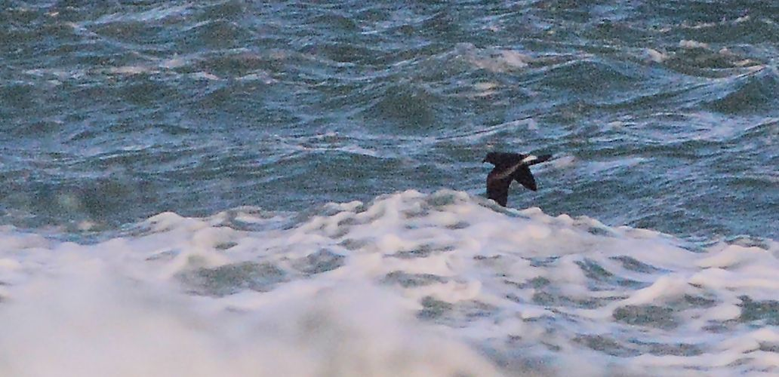
Leach’s Petrel on 21st – a NW storm event speciality at MSBO

Seawatching picked up on 24th, most unusually, in a SW-WSW strong wind. Did the remnants of the hurricane a few days earlier leave the seabirds susceptible to these continuous strong winds? The first early morning indication of promising seawatch was the gradual arrival / intermittent passage >S of predominantly adult Great Northern Divers (c. 40 birds throughout the day with the majority in breeding plumage), reasonable numbers / moderate passage of Black-legged Kittiwakes and a Pomarine Skua. The day total of scarce passage visitors within sight of the shore increased later and included a Great Skua, 10 Pomarine Skuas, a Little Gull and a Puffin (rare in October).
The 25th was another exciting day with our first committee-level rarity of the autumn - a juvenile Long-tailed Skua. Also passing S were 4 Great Skuas, 3 Pomarine Skuas and another Little Gull. Throughout this two-day seawatching event a total of 1,700+ Black-legged Kittiwakes >S / 12hrs. With such a steady volume of Kittiwakes, a late juvenile Sabine’s Gull close to the shore was absolutely top of our wish list: well... we wished in vain! Looks like a blank autumn for this high arctic gem - Grey Phalarope too.
Later, a first-winter Mediterranean Gull >S and 2 late Swallows >N, both these records on 28th, and no fewer than 3 juvenile Little Gulls on 31st.

News from around the peninsula...
Away from MSBO there was a Little Egret at West Loch Tarbert, 2 Yellow-browed Warblers trapped / ringed at Loch Lussa and 2 Magpies still frequenting Campbeltown.
Then, at 10:44hrs on 24th, a monocle-dropper – a Wilson’s Petrel in Kintyre! Dan Brown reported this mega at Tayinloan ferry jetty (mid-west Kintyre). When found the petrel was, unfortunately, clamped firmly in a Herring Gulls bill, and, was still alive! A Great Black-backed Gull then robbed the HG of its prize and drowned the petrel. Dan emphasised there had been no time to photograph the unfolding drama: however, he did manage to glean some satisfactory plumage details and felt confident with his identification to species level.
This was truly a bizarre encounter: what a pity the evidence was swallowed, aye whole! Still, it may well become the second Argyll record of this trans-equatorial migrant that breeds on the Antarctic continent.
The first Argyll / Scottish occurrence concerned one caught alive on Jura in October 1891 (ap Rheinallt et al 2007; Birds of Argyll).

Selected Species List

Whooper Swan
Flocks >S included 11adults on 6th, 18 adults on 10th, 5 adults on 11th, 12 including 5 juveniles on 23rd, 22 adults on 24th, 25 adults on 25th and 3 adults on 27th.
Total = 96 birds >S MSBO on seven dates.
The only northerly movement noted was 5 adults on 14th.
Campbeltown: Flock 11 adults >E on 17th.
After very heavy rain on 16th, 5 adults appeared at a small pool by Aros Farm, The Laggan. These are the first birds seen on the ground and the first floodwater noted anywhere in The Laggan fields this autumn. Later, a flock 30 at Kilmichael Farm, by Campbeltown on 23rd (Dan Brown pers. comm.).

Brent Goose
Flock 17 >S on 21st.

White-fronted Goose
Flocks >S included 30 on 21st and 7 on 25th.

Pink-footed Goose
Five flew in off sea then >E on 6th.

Pintail
A female-type was photographed >S on 18th.

Wigeon
Flock 10 >S on 5th.

Common Eider
Top count this month was only 36 on 22nd (included 26 adult male, 2 immature male and 8 female).

Common Scoter
Southerly movements: an adult drake on 5th, five on 15th, three on 18th, single adult drakes on 25th and 27th.

Goosander
A redhead was photographed >S on 30th.

Red-throated Diver
A total 16 >S on three dates 3rd – 5th with half of these in / 4hrs on 3rd. Five singles >S on 24th. Six >S on 25th. One’s / two’s >S / on sea all dates later.

Black-throated Diver
Singles on 23rd and 31st.

Great Northern Diver
Three >S (together) on 1st. Total of 11 (9 adults) >S / 7hrs during storm event on 21st.
Obvious arrival / passage of adults on 24th with 32 >S / 7hrs (largest loose group 7) and at least 8 on the sea. Twelve adults >S / 5hrs on 25th. Eight adults >S on 30th.
Typically the main arrival / passage period of adults from northern breeding grounds.

Little Egret
Kennacraig, NW Kintyre. The bird reported at the West Loch last month (Jim Dickson pers. comm.) was still present on 1st (Davie Robertson pers. comm.).

Manx Shearwater
Two >S / 7hrs during a storm event seawatch on 21st. Three >S on 31st.
The only records this month.

Wilson’s Petrel (Vagrant)
One Tayinloan ferry jetty on 24th had been caught by a Herring Gull: it was soon taken by a Great Black-backed Gull then drowned before being swallowed whole (Dan Brown pers. comm.)
If accepted by British Birds Records Committee this will become the second Argyll record and about the fifth Scottish occurrence (The Birds of Scotland: Forrester et al 2007).

Leach’s Petrel
One photographed >S during a storm event on 21st.

Northern Gannet
Juveniles passage data only: a total of 11 >S on seven dates 16th – 29th including 4 / 6hrs on 19th.

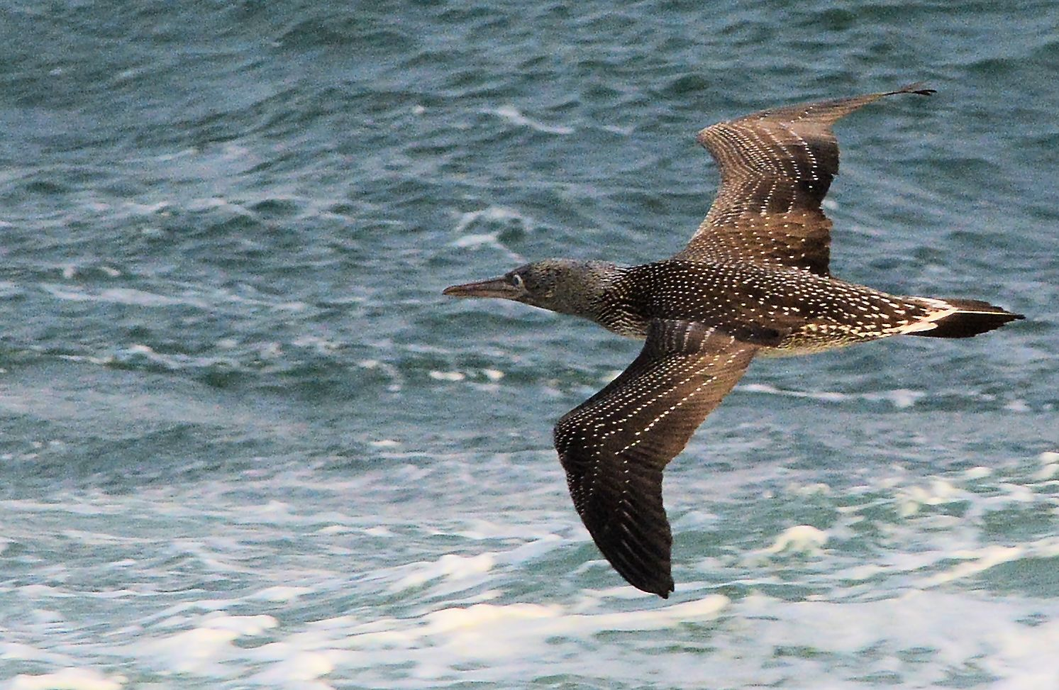
The striking plumage of a juvenile Northern Gannet

Water Rail
One was seen well on 19th from the bridge at Glenramskill water mouth, Campbeltown Loch (Marjorie Fraser et al / pers. comm.).

Golden Eagle
A sub-adult was seen by The Bastard, SE Kintyre on 24th (Martin Conway pers. comm.).

Hen Harrier
A ringtail was at Pennyseorach, near Southend 25th-27th (Annie Cunningham).

Sparrowhawk
Seen almost daily hunting along the shore – several birds are thought to have been involved.

Merlin
A first-winter was photographed by MSBO on 16th.
Records later included singles on 19th, 20th, 23rd, 25th, 30th and 31st.

Sanderling
Passage flocks >S included c.25 on 2nd, 18 on 5th, 10 on 6th, 60 on 12th and five flocks totalling 63 during a storm event on 21st.
Machrihanish Bay: 40 on 7th.

Red Knot
A juvenile was photographed on 7th.
This normally regular passage visitor has been extremely scarce, as have many other wader species, this autumn.

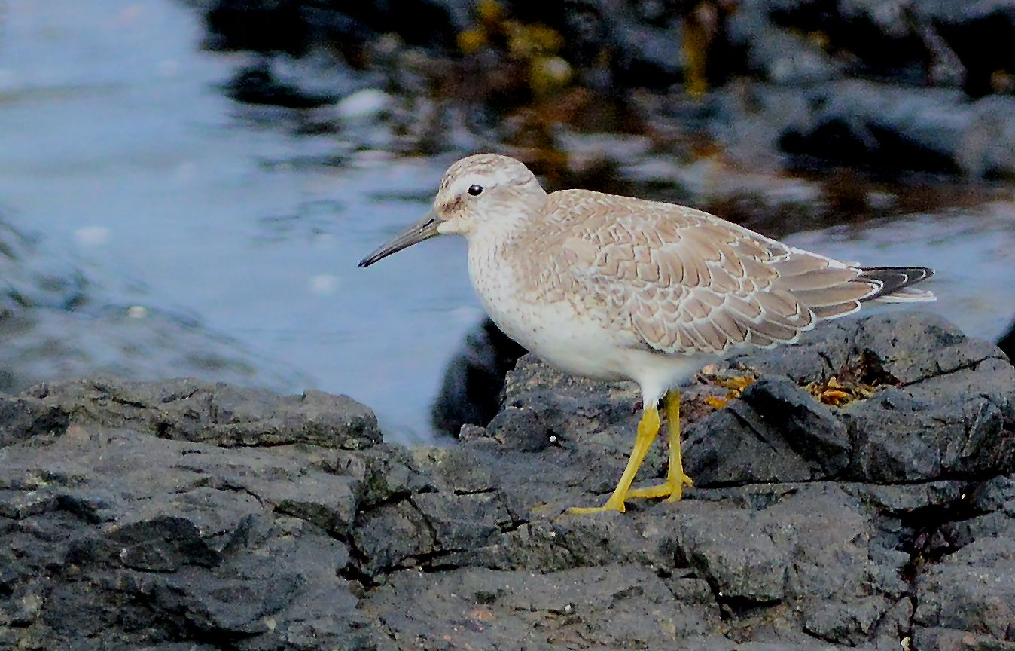
Red Knot (juvenile – c. 30m from MSBO)

Purple Sandpiper
A single bird on 2nd was the first seen this autumn. One >S on 21st. One >S on 26th.
Ten regular on the point from 27th.

Great Skua
Singles > S on 18th and 24th with 4 singles / 5hrs on 25th.

Pomarine Skua
A total of 10 >S / 7hrs (8 first-winter and 2 adults) on 24th (5 singles and a very loose group of 5)
Most (9) occurred pm and their appearance coincided with an increase in a southerly movement of Black-legged Kittiwakes from moderate to heavy (see below).
Next day (25th) 3 juveniles (singles) >S / 5hrs (all am).
A typical October period for the occasional appearance of mainly first-winter birds off western Scotland.

Long-tailed Skua
A juvenile / first-winter >S at 12:07hrs on 25th.
This is a very scarce (mainly autumn) gale driven passage visitor to the SW coast of Kintyre in very small numbers.

Mediterranean Gull
A first-winter >S on 28th (too close to photograph!).
The third MSBO record this autumn.

Little Gull
Single first-winter birds >S on 24th and 25th then at least 3 first-winter were foraging offshore for almost 2hrs pm on 31st.
The first MSBO records this year and the best showing for a number of years.

Black-legged Kittiwake

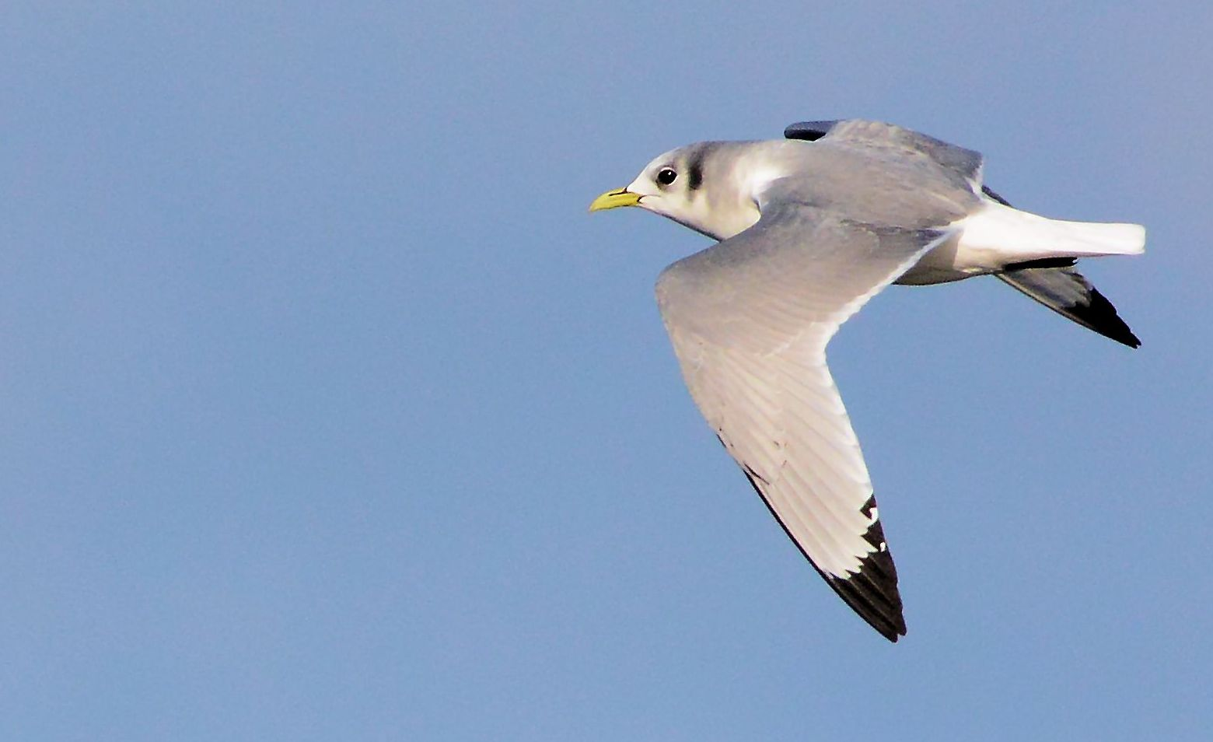
Black-legged Kittiwake

Flock 600 Machrihanish Bay on 11th: eventually all >S.
Horizon flocks >S totalled 2000+ on 18th.
Total of only 440 >S / 7hrs during a storm event on 21st (70% were juveniles).
A total of 670 >S / 7hrs on 24th. Passage was moderate and predominantly pm but peaked at only 8 - 12 birds per minute.
A total of 1,100 >S / 5hrs on 25th (peak was 33 birds per minute at 09:33hrs).

Razorbill / Guillemot
Continuous small trains > S on 18th totalled 700+ / 3hrs.
Puffin
One >S on 24th.
A most unexpected visitor here in October (and mostly any other time except May and August).

Swallow
The last record of the month was 2 >N on 28th (Eddie Maguire / Iomhar McMillan / Grant and Carolyn Pearce).
Wheatear
Late birds included one on 19th and 2 on 25th.

Whinchat
A female-type was at Machrihanish Holiday Park on 22nd (Martin Conway).

White Wagtail
Daily in very small numbers to 17th (3).

Yellow-browed Warbler
Two birds trapped / ringed at Lussa Forest on 10th (Argyll Bird Club website / see Recent Reports section).
An extremely rare W coast mainland occurrence and the first Kintyre record.

Magpie
Two birds are still resident in Campbeltown and have been reported regularly by local folk (Bob Middleton et al / pers. comm.).

Starling
Flock 800+ on 12th. Flock 1,700+ at Drumlemble on 21st.

Brambling
A single bird at the feeding station on 12th was joined by another on 13th. One appeared there again on 17th.
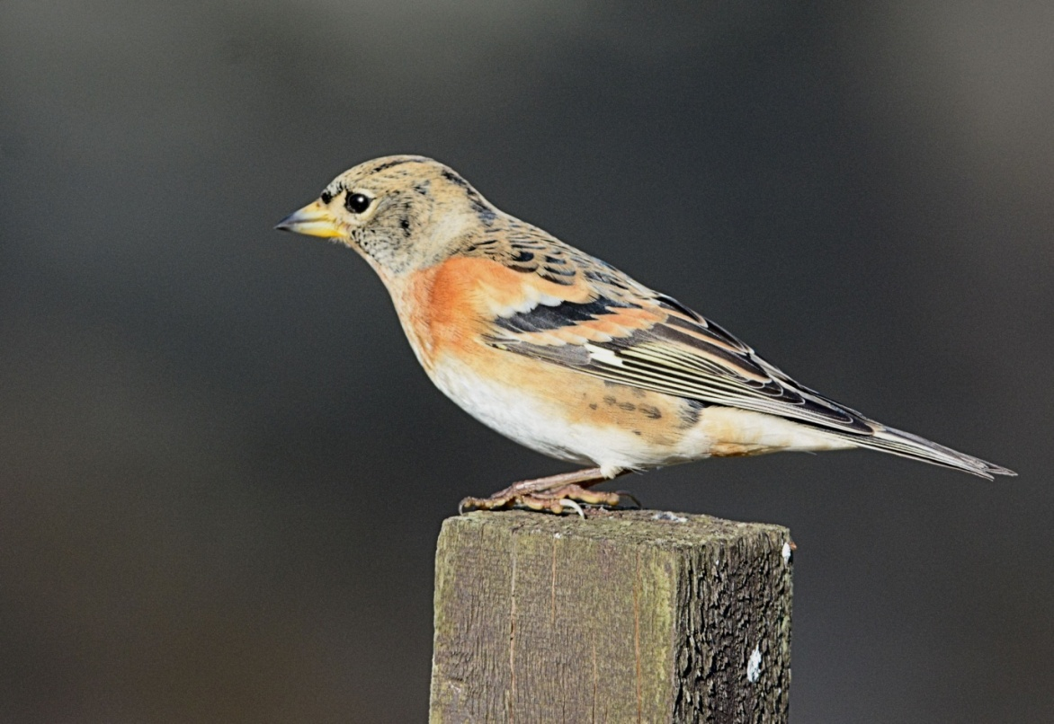

Brambling

A few more photos from October
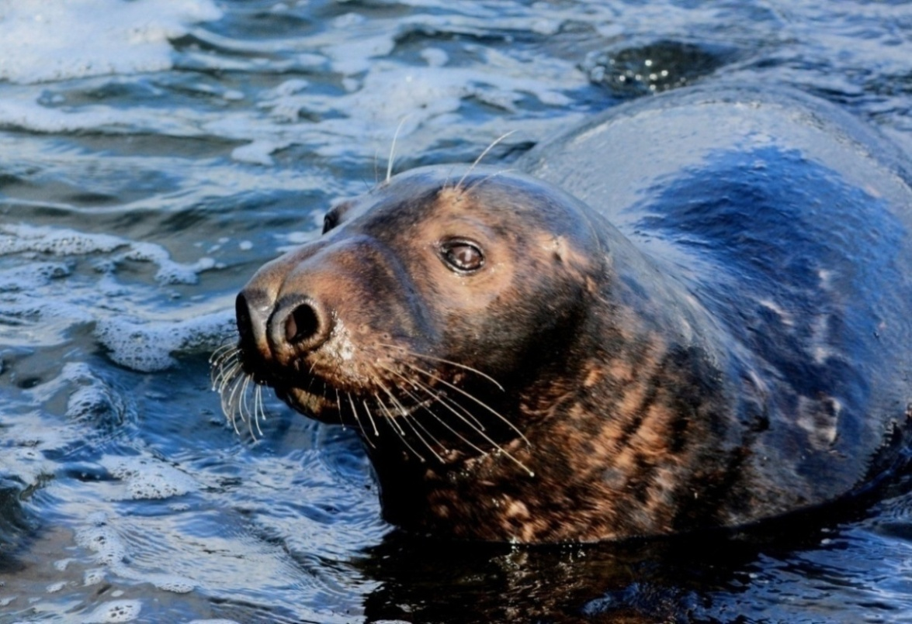
Grey Seal
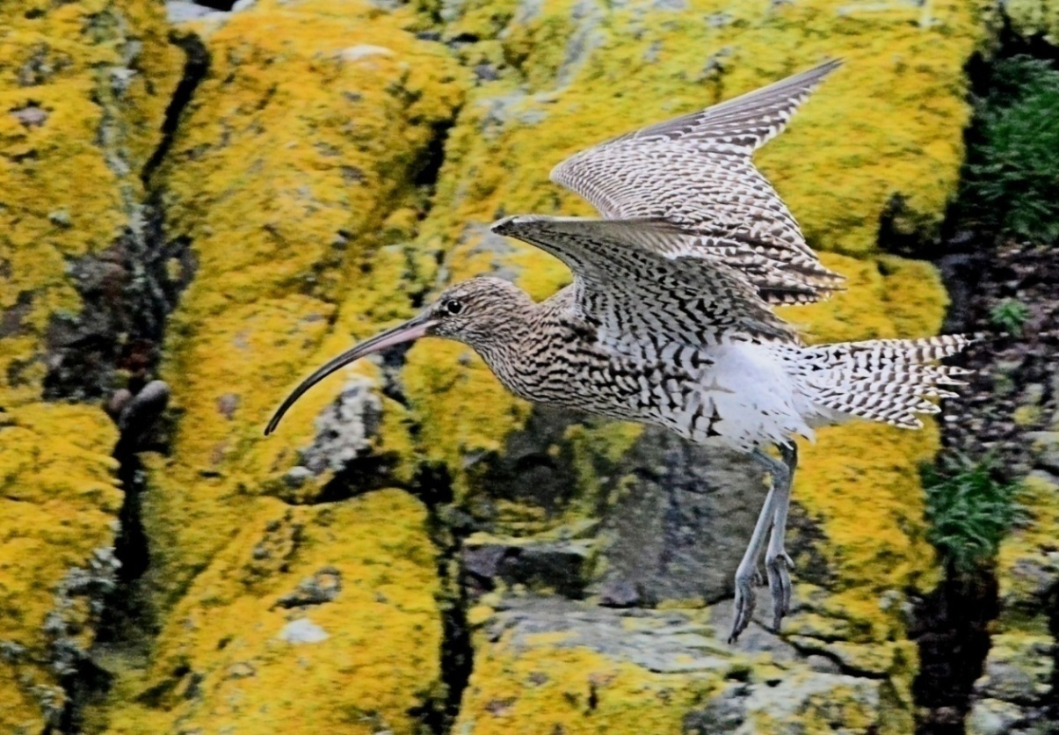
Curlew
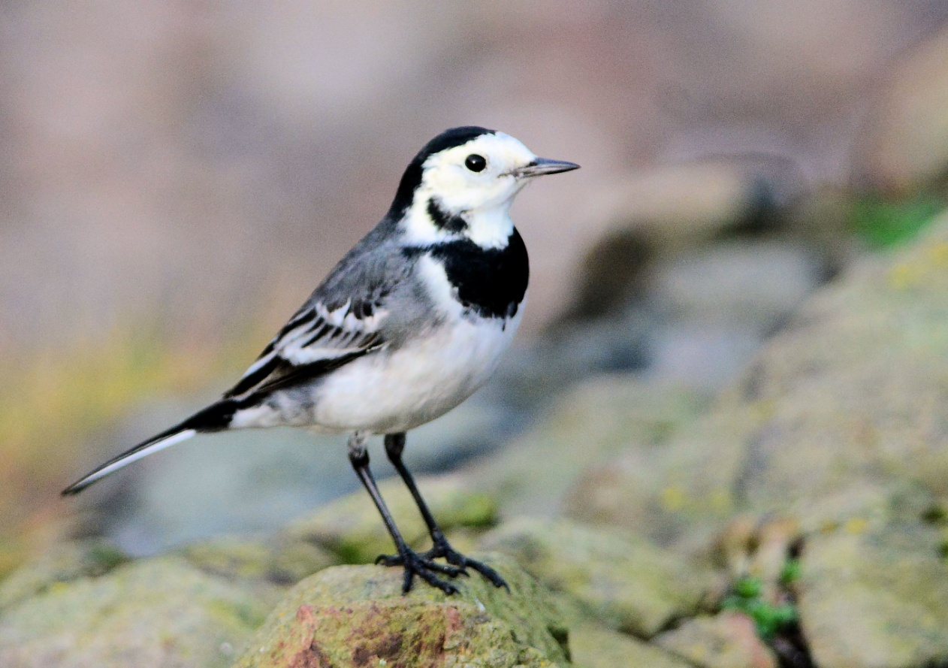
Pied Wagtail

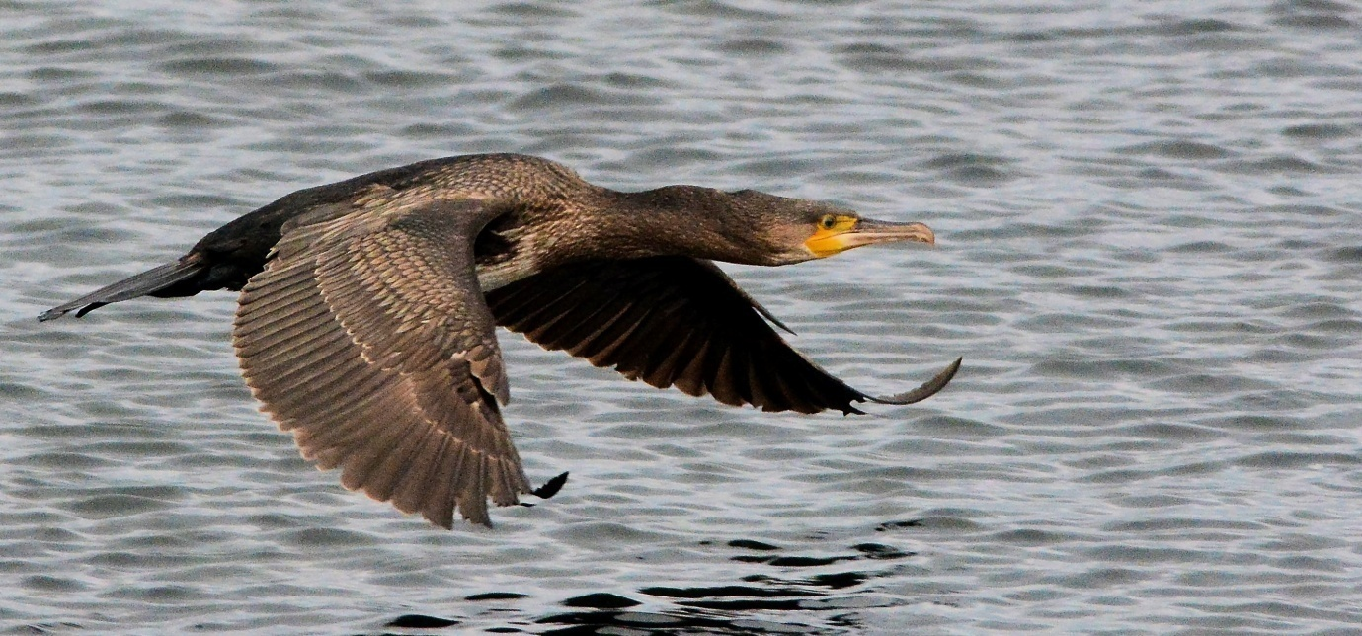

Cormorant >N off MSBO

